RANIGANJ CUSTOMER CARE CENTER, PHONE No - 444571

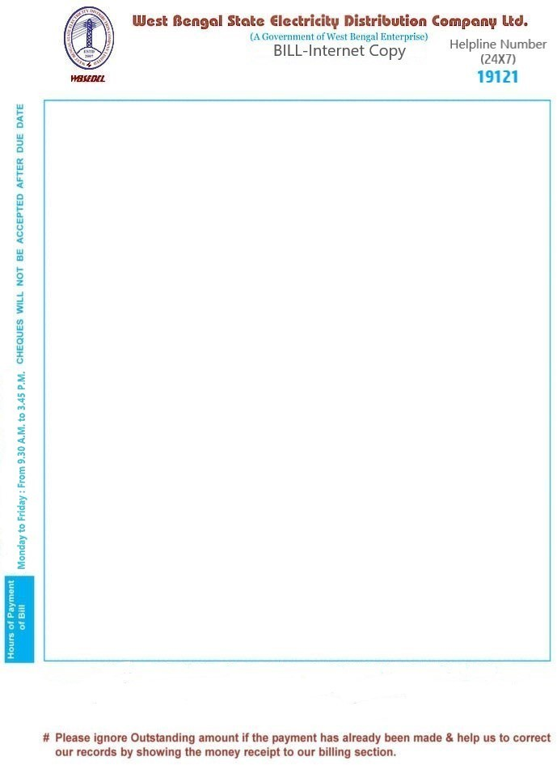

OFFICE OF THE S.M., CALL CENTER PHONE No - 19121(TOLL FREE), TAN: CALW05053G SMT.PUTUL SAHA Invoice No. : 446015302738 GOURDNGA DANGA COLONY RAMBAGAN Prev. Reading Date : 31.05.2024

|  |  |  |  |  |  |  |  |
| --- | --- | --- | --- | --- | --- | --- | --- |
| PO.SEARSOL,RAJBARI | | | Present Reading Date : | | | | 30.08.2024 |
| Pin - | | | Billing Date : | | | | 30.08.2024 |
| Consumer Id : | | | 513076984 | | Next Reading Date:18.11.2024-22.11.2024 | | |
| Tariff Class : | | | A(DM-U) | | Connected Load : 2.35 KVA | | |
| Installation No : | | | 4434711 | | Solar PV Capacity : | | |
| Latitude : | | | 23.6127353 | | Meter Reading unit : F1S01QMR | | |
| Longitude : | | | 87.1240512 | | PAN of consumer(s) : | | |
| Meter No  T03162768 | Time  N | Previous Reading 6864.00 | | Present Reading 7851.00 | MF  1.00 | Unit consumed 987.00 | Max Demand  (KVA) |

|  |  |  |  |
| --- | --- | --- | --- |
| Bill Month | SEP,2024 | OCT,2024 | NOV,2024 |
| Amount due after due date(Rs.) | 2735.00 | 2736.00 | 2736.00 |
| Due dates to avail Monthly Rebates | 09.09.2024 | 21.10.2024 | 11.11.2024 |
| Monthly Rebates(Rs.) | -24.79 | -24.79 | -24.80 |
| Amount due within due dates(Rs.) | 2710.00 | 2711.00 | 2711.00 |
| Special Rebate(Rs.)  Total Amount Payable at a time within | -98.70  1st Due date* | (Rs.) | 8,032.00 |
| Amount payable at a time through e-Payment within 1st Due date | | | 7,959.00 |
| Breakup of Charges Category | Total | | |
| Energy Charge(Rs.) | 7227.36 | | |
| Fixed/Demand Charge(Rs.) | 211.50 | | |
| Meter Rent(Rs.) | 30.00 | | |
| Electricity Duty(Rs.) | 736.45 | | |
| Gross Amount(Rs.) | 8205.31 | | |
| Adjustments** | -0.97 | | |

Payment may be made using RTGS/NEFT in your exclusive a/c no: WBB5130769844711 with IFSC ICIC0000104 or SBIN0004266

As per order of WBERC dated 06.03.2024 & Subsidy from West Bengal Govt # Outstandings: Rs.0.00

Last Payment Details:Amount(Rs.):1635.00 Payment date :03.07.2024 Security Deposit: Rs. 4603.70